ALL INDIA INSTITUTE OF SPEECH AND HEARING
अखिल भारतीय वाक एवं श्रवण संस्थान
DEPARTMENT OF SPECIAL EDUCATION
विशेष शिक्षा विभाग
JANUARY MONTHLY REPORT 2017
- ACADEMIC ACTIVITIES
- Short-term Training Programs: NIL
- Faculty report
- Dr. M. Pushpavathi – HOD in Special Education

- Attended a meeting related to the Deemend university in the borad room on 31.1.17
- Attended HoD s meeting on 31.1.17
- Conducted faculty meeting on 20.1.17

- Dr. G. Malar, Reader in Special Education
- CBCS Coordinator & Mentor for I & II B.Ed.Spl.Ed. (HI) – 50 hours
- Coordination & supervision of field engagement of II B.Ed. students in mainstream school – (round 1) in 2 schools
- Coordination for field engagement of II B.Ed. students in special schools/ institutions ( round 1) – including communication with authorities & drafting related documents
- Coordination of practicum posting of I B.Ed. students
- Conduct of monthly meeting & compilation of attendance
- Drafting of communication to HODs for I B.Ed. C1 evaluation & distribution
- Coordination of SEA-U Activities – 5 hours
- Coordination of faculty postings
- Compilation of monthly statistics
- Preschool Supervision – 20 hours
- Meeting with caregivers in 10 groups & follow up of planning & execution of lessons
Classroom observation of 3 sessions

Name of the Faculty |  | Dr. Alok Kumar | Dr. G. Malar | Dr. Prithi Venkatesh | Dr. P. Vijetha
Clinics
No. of cases evaluated at SEA-U |  | 18 | Screening: 7  Assessment: 1 | 07 | 12
No. of cases supervised individually |  | 00 | 16 children in 3 groups thru’ 3 sessions of classroom observations | 14 observations | NIL
No. of groups supervised |  | 13 | 10 | 10 | 32
No. of meeting with parents |  | 10 | 10 | 10 | 10
Educational Guidance |  | 00 | Clients: 12  Sessions: 15 | 1 | 04 (11 sessions)
Academic (Classes not commenced for the month of June 2016)
Classes taken
B.Ed.  Spl.Edn(HI) | Theory | 29 classes | 30 sessions | 14 classes | 30 classes
B.Ed.  Spl.Edn(HI) | Practical | 12 hours | 53 hours |  | 25 hours
DECSE(HI) | Theory
DECSE(HI) | Practical
Any other |  |  |  | Attended half day orientation program on ‘MED-EL Rehab Programme’on 02.01.2017 organized by the Department of Audiology  Attended Peer Evaluation of Department of Clinical Psychology  Attended workshop on New Horizons in Inclusive Education’ organized by the Department of Special Education on 13.01.2017  Prepared and submitted proposal for conducting five day short term training programme for special educators from Maldives. | - Served as Invigilator for PG exams of UOM.  - On 3rd January 2017 participated in 17th National Scouts and Guides Jamboree, Exhibition of the Institute.  - On 16th January 2017 Submitted format for evaluation of B.Ed. I and II year trainees.  - Supervised the practice teaching sessions in regular schools of B.Ed. II year trainees.  - Correction of B.Ed. Lesson plans in social sciences.  - Attended Peer evaluation of Dept. of Clinical Psychology on 11th January 2017.
Research
Paper published |  | NIL | 02 | 1 paper published.  Prithi, V., Malar,G and Sumana , H.P.(2016). Sources of stress in Educators of Mainstreamed Children with Hearing Impairment. Guru Journal of Behavioural and Social Sciences. Vol 4 (3). Pp560-569.
Paper in press/ in progress |  | 04 |  | One Chapter in a book ‘ICT for Children with Special Needs’ | Submitted paper titled “Impact of Early intervention by a Multidisciplinary team on development of a child with hearing impairment: A case study ” to be reviewed and published in JNCED 2017
Paper presentation |  | As served as a Resource Person in National Seminar on New horizons in inclusive education and topic” Best practices in inclusive education”
ARF Project |  |  | Sanctioned 1 |  | “Efficacy of self learning adapted social studies lessons in Kannada and Telugu for children with hearing impairment at Secondary School Level”.  Final Report for review was submitted on 19th January 2017 in the prescribed format.
Thesis Evaluation/Project Review
Any other
Meeting held |  | Infant & Toddler Unit meeting conducted on 20.01.17 reg. preparation of new manuals. | - 2 monthly meetings with I & II B.Ed. student.  - 2 meetings with members of Open Day Committee for CWSN |  | - From 24th to 31st January 2017,held meetings with team members for Open day Exhibition committee.
Meeting attended |  | 1. Meeting with HOD reg. Units reform.  2. Preschool meeting attended on 27.01.17 at AV Room.  3.Meeting attended on Open day- Special Events at Board room held on 18.01.17 | 2 with HOD – Special Education | --Meeting with HOD on 20.01.2017 for updating about the progress made in the preschool  --Open Day meeting in the Board Room for discussion about catering (18.01.2017)  --Conducted two rounds of meeting with members of hindi team for hindi material development (20.01.2017 and 25.01.2017)  --Meeting with Special Educators to discuss about ‘Swatch Bharath’ Drawing competition and other issues related to preschool.  --Meeting with Chairperson Catering Committee and other members for discussing about Open Day (28.02.17) | Attended meeting with HOD on 20th January 2017 regarding the progress achieved for the unit Service for School aged children
AV preparation
Brochures
Orientation Programme
Workshop |  |  |  |  | - Coordinated in preparing the Report of the Workshop held on 9th and 10th October 2016 and submitted to DDPI office.  - Attended the workshop “New Horizons in Inclusive Education” on 13th January 2017.  - Coordinated in preparing the draft proposal for Workshop to be held for Teachers from Maldives in the month of March 2017.
Roles & Responsibilities
Co-ordination |  | Infant & Toddler Unit | - CBCS Coordinator for I & II B.Ed. Spl.Ed. (HI)  - Mentor for I & II B.Ed.Spl.Ed. (HI)  - Compilation of M.S.Ed. Student Dissertation-based Articles 2014-15  - Intra-Department  - SEA-U  - EduTechLab  Research & Database Unit |  | Coordinated Registration arrangements for the workshop held on 13th January 2017 along with respective special educators.  Service for School aged children  - As a part of Mainstream school adoption program, videos for PPT presentation for Orientation program II are being prepared.  - Pre-test and I orientation program has been completed in two schools on 9th and 30th January 2017.
Member secretary |  | Preschool | - LD Clinic (in DCS)  - Services for School-Aged Children (in Department of Special Education) | Serving as member secretary for Catering Committee for Open Day Celebration  Serving as member secretary for SEAU in the Department of Special Education | Service for Infant and Toddlers
Member in |  | SEA-U | - TCPD  - Product Development Cell  - Evaluator for UoM UG courses in special educator  Preschool Supervision | SEA-U | SEA –U  Prepared school readiness reports of four clients and submitted
Mentor |  | M.Sc. -1st Year -Audiology
- Orientation Programs:

Name/Topic of the Program | Coordinator | Objectives | Targeted Audience | Number of Participants | Date
Orientation on Preschool Training for Children with Communication Disorders | Mr.Gururaj D. | Developing awareness on preschools education for Children With Special Needs | Chitra Gurukumar, Resource Consultant, Special Education, Bangalore | 01 | 20.01.17
Orientation on Preschool Training for Children with Communication Disorders | Mr.Gururaj D. | Developing awareness on preschools education for Children With Special Needs | ASHA Kasaba I & Melkote hobli, mandya District | 73 ASHA workers | 24.01.17
Orientation on Preschool Training for Children with Communication Disorders | Mr.Gururaj D. | Developing awareness on preschools education for Children With Special Needs | ASHA  Kasaba & Davadagere hobli, Mysuru District | 52 ASHA workers | 25.01.17

- Seminars/Conferences/Workshops:
Name/Topic of the Program | Coordinator | Organized by Dept./Section/Unit | Targeted Audience | Number of Participants | Date
National Seminar on “New Horizons in Inclusive Education” | Dr. Alok Kumar Upadhyay &  Ms. Manjula P.V | Department of Special Education | Regular & Special School Teachers | 100 | 13.01.2017
Photo:

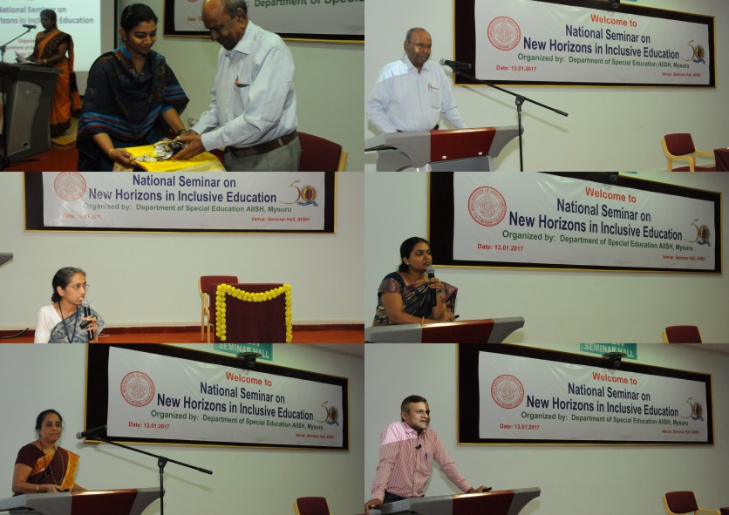

- In- house training Programs: NIL
- Staff Enrichment Programs (SEP’s) : NIL
- Empowering Educators in Education (E³): NIL
- Guest Lectures :
- Invited Talks: 02

The following papers have been presented at National Seminar on New Horizons in Inclusive Education at All India Institute of Speech and Hearing, Mysuru, 13th January 2017.

SL No. | Date | Resource person | Topic
1 | 13.01.2017 | Dr. Alok Kumar Upadhyay | Best practices in inclusive education
2 | 13.01.2017 | Dr. G. Malar | Changing Roles of Special Education - In Present Scenario

- Development of Materials to Support Learning
- Service in Academic bodies of other Organizations- NIL
- Membership in Professional Organizations/Associations - NIL
- Participation in Committees/Taskforce and Panels setup by other organizations/agencies-
- Any Other (Please Specify).

- RESEARCH ACTIVITIES
- Research Projects
- Completed Research Projects: 01 (ARF)

ARF project titled “Efficacy of self-learning adapted social studies lessons in Kannada and Telugu for children with hearing impairment at Secondary School Level”
- The project work started on 8th January 2016
- The final report for review was submitted on 19th January 2017

- New Research Projects: 02
- On-going Research Project : NIL
- Doctoral and Post-Doctoral Programs: NIL
- Degree Awarded:
- Thesis awarded:
- Thesis Submitted:
- Under Progress:
- Research Papers presented at National/International Conferences/Seminars:NIL
- Research Papers Published(in APA format):
    - Papers published in Conference/Seminar Proceedings
    - Research Papers in press- NIL
    - Research Papers published in Journals: 02

Dr. Vijetha P: Submitted paper titled “Impact of Early intervention by a Multidisciplinary team on development of a child with hearing impairment: A case study ” to be reviewed and published in JNCED 2017. (In Press)

Prithi, V., Malar,G and Sumana , H.P.(2016). Sources of stress in Educators of Mainstreamed Children with Hearing Impairment. Guru Journal of Behavioural and Social Sciences. Vol 4 (3). Pp560-569.

    - No. of in-house journal articles:
    - Books published.

- Book chapters published(in APA format)
- Books in press :
- One Chapter in a book ‘ICT for Children with Special Needs’.
- Books/Manuals/Seminar Proceedings edited
- Journal Editorship
- Scholarly Reviewing Activities
- Reviewer for Scholarly Journals
- M.S.Ed (HI) Dissertations Guided by Faculty
- Clinical Support Services to Patients and Family
- Details of Certificates Issued:

Details of Bonafide Certificates Issued:

Sl.No. | Nature of Special Needs in Clients | No. of Certificates Issued | Purpose
1 | DSL,MR | 01 | - Applying for pension
2 | DSL, HL | 01 | - For open bank account
- Clinical Electronic Services: NIL
V) CENTRAL FACILITIES
      - Library and Information Services
      - Public Information Activities
- Major Events of the month of December with a brief account:
- Press Releases and Media Coverage
- Institute Publications -
- Material Development

Sl.  No. | Nature of Teaching-Learning Materials | Skill | Number
1. | Flash cards | For all skill areas | 299 sets
2. | Work Cards | For all skill areas | 213 sets
3. | Charts | For all skill areas | 19
4. | PPT | For all skill areas | 65
5. | Models | For all skill areas | 3
6. | Sentence strips | For all skill areas | 209 sets
7. | Others | For all skill areas | 7
- AWARDS AND HONORS RECEIVED BY FACULTY AND STAFF
- EXTRA CURRICULAR ACTIVITIES
- Others:
IX. EMINENT VISITORS: NIL
X. ANY OTHER
- Official Language Implementation:
- One word a day in Hindi.
Parent Help Parents Program (PHPP): 1
- SPECIAL EDUCATIONAL SERVICES
Name of the faculty/ staff | Mrs. Prafulla , Parent of Ullas (23 years)
Name/Topic of the Program | Parents help parents programme(PHPP) for Parents of children
Coordinator | Ms. Latha C., Ms. Anjana K., Mr. Raj Kumar, Mr. Gururaj D., , Mr. Harish Kumar
Objectives | - To help instil confidence in the parents/caregivers handling their child.  - To train the parents in managing their stress levels while dealing with their child.  - To motivate the parents for working more efficiently with their child.  - To empower the parents regarding different aspects of training
Organized by Department/Section/Unit | Department of Special Education
Targeted Audience | Parents of Special Children
Date | 25.01.2017
No.of beneficiaries | 130
Photo
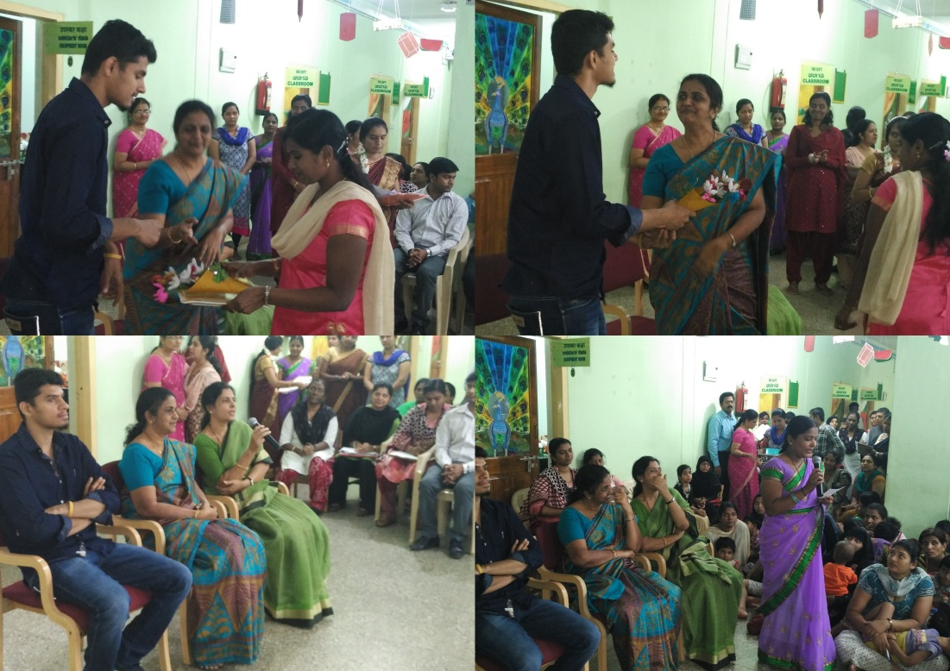

- Pre-School Training and Special Education
  - Monthly Statistics Special Educational Services

S. No. | Nature of Services (I/C)
- Special Educational Assessment Services (Dr. G. Malar)
 |  | Nature of Special Need  Language |  | ASD / PDD NOS | Hearing Loss | Intellectual Disability |  | Learning Disability | Motor Problems |  | Multiple Disabilities | Others | No. of Clients | No. of Sessions | Total No. of Sessions
1. | Screening & Referral | Kannada |  | 2 | 3 | 4 |  | - | 1 |  | 5 | 4 | 19 | 19 | 46
1. | Screening & Referral | Malayalam |  | - | 3 | 7 |  | 1 | 1 |  | 6 | 3 | 21 | 21 | 46
1. | Screening & Referral | Hindi |  | - | - | - |  | - | - |  | - | - | 0 | 0 | 46
1. | Screening & Referral | Urdu |  | 1 | - | - |  | - | - |  | - | - | 1 | 1 | 46
1. | Screening & Referral | English |  | - | - | - |  | - | - |  | 1 | - | 1 | 1 | 46
1. | Screening & Referral | Telugu |  | - | - | 2 |  | - | - |  | - | - | 2 | 2 | 46
1. | Screening & Referral | Tamil |  | - | 1 | - |  | - | - |  | - | - | 1 | 1 | 46
1. | Screening & Referral | Any Other |  | - | 1 | - |  | - | - |  | - | - | 1 | 1 | 46
1. | Screening & Referral | Total No. of Clients |  | 3 | 8 | 13 |  | 1 | 2 |  | 12 | 7 | 46 | 46 | 46
2. | Assessment & Report | Kannada |  | - | - | 1 |  | - | 1 |  | 1 | 1 | 4 | 8 | 14
2. | Assessment & Report | Malayalam |  | - | - | - |  | - | - |  | - | - | - | - | 14
2. | Assessment & Report | Hindi |  | - | - | - |  | - | - |  | - | - | - | - | 14
2. | Assessment & Report | Urdu |  | - | - | - |  | - | - |  | - | - | - | - | 14
2. | Assessment & Report | English |  | - | 1 | - |  | - | - |  | - | - | 1 | 5 | 14
2. | Assessment & Report | Telugu |  | - | - | 1 |  | - | - |  | - | - | 1 | 1 | 14
2. | Assessment & Report | Tamil |  | - | - | - |  | - | - |  | - | - | - | - | 14
2. | Assessment & Report | Any Other |  | - | - | - |  | - | - |  | - | - | - | - | 14
2. | Assessment & Report | Total No. of Clients |  | - | 1 | 2 |  | - | 1 |  | 1 | 1 | 6 | 14 | 14
2. | Places from which seen: (1)Karnataka: 25 (2)Kerala: 19 (3)AP: Nil (4)TN: 1 (5)Other Parts of India: 1 – Puducherry (6)Any other: 1 Nil
2. | Age groups seen:(1)Birth to 2.5yrs: 5 (2)2.5⁺ to 6 yrs: 18 (3)6yrs⁺ to 16 years: 22 (4)16yrs⁺: 2
2. | Total No. of Referrals: (1)Educational Assessment: 5 (2)Educational Guidance: Nil (3)PIP: 3 (4)PPEP/ PBC/ GECS: 23 (5)CSS/IEP/NFE/DET: 15 (6) Any Other Services at AIISH: 1 (7) Any Other Services Outside AIISH: 1 (mainstream educational services)
2. | No. of Reports Issued: (1) Early Development Skills: Nil (2) School Readiness: Nil (3) Curriculum-Based Assessment: 1 (4) Post-School Preparedness: Nil
3. | On-going Assessment (as part of service delivery) |  | Figure: 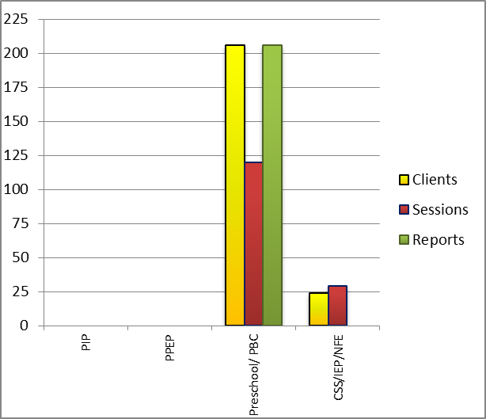
 | Details of Assessments |  | No. of Children |  |  |  | No. of Assessment Sessions |  |  | No. of Reports
 | As part of Parent-Infant Programme: |  | Nil |  |  |  | Nil |  |  | Nil
 | As part of Preschool Parent-Empowerment Programme: |  | Nil |  |  |  | Nil |  |  | Nil
 | As part of Preschool Training Programme &  As part of Preschool Bridge Course Programme: |  | 206 |  |  |  | 120 |  |  | 206
 | As part of CSS/ IEP/NFE: |  | 24 |  |  |  | 29 |  |  | Nil

Preschool Training (Ms. Prithi Venkatesh):Preparatory programme for schooling providing training in self-help, cognitive, language and (pre) academic skills, Preschool Bridge course
Language & Disability | No. of Groups | No. of Children
 |  | MALE | FEMALE
Kannada ID | 12 | 18 | 12
Kannada MD | 12 | 5 | 2
Kannada ASD | 12 | 3 | 0
Kannada Others | 12 | 11 | 4
Kannada HI | 10 | 41 | 35
Malayalam HI | 1 | 3 | 4
Malayalam ASD | 10 | 11 | 0
Malayalam MD | 10 | 6 | 7
Malayalam ID | 10 | 10 | 7
Malayalam others | 10 | 3 | 1
Hindi HL | 1 | 5 | 1
Hindi MD | 2 | 2 | 1
Hindi ID | 2 | 3 | 2
Hindi ASD | 2 | 2 | 0
English ID | 2 | 3 | 4
English ASD | 2 | 3 | 4
TOTAL Number of children |  | 126 | 80
TOTAL No. Groups | 38 | 206
Sessions | 3840 (Group wise) 24 days

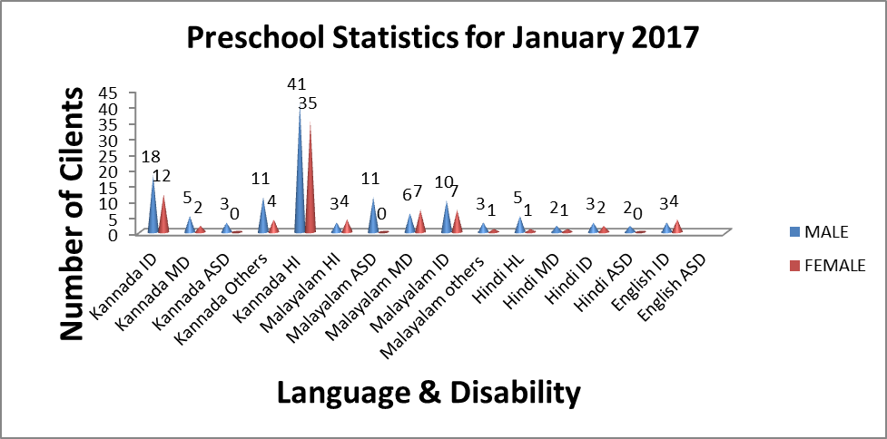

Curricular Support Services – Supportive training to augment education in mainstream school/ other educational programmes – Ms. Shobha B N
 | Language | HL | MR/CP/Down’s/LD | PDD | Total No.of clients | No. Of sessions
 | Kannada | 04 | 14 | -- | 18 | 115
 | Malayalam | -- | 02 | -- | 02 | 09
 | Hindi | 02 | 02 | -- | 04 | 19
 | English | 01 | 01 | 01 | 03 | 18
 | Telugu | -- | 01 | -- | 01 | 06
 | Tamil | -- | -- | -- | -- | --
 | Total |  |  |  | 28 | 167

Individualised Educational Programme (IEP) – Training in functional academics for out of school individuals– Ms. Shobha B N
 | Language | HL | MR/CP/Down’s/LD | PDD | Total No.of clients | No. Of sessions
 | Kannada | 01 | 04 | -- | 05 | 33
 | Malayalam | 01 | 02 | -- | 03 | 07
 | Hindi | -- | -- | -- | -- | --
 | English | -- | -- | 01 | 01 | 2
 | Telugu | -- | -- | -- | -- | --
 | Tamil | -- | -- | -- | -- | --
 | Total |  |  |  | 09 | 42

Demonstration Training – Short-term demonstration to caregivers in any of the above –
Ms. Shobha B N
Language | HL | MR/CP/Down’s/LD | PDD | Total No.of clients | No. Of sessions
Kannada | -- | -- | -- | -- | --
Malayalam | -- | 01 | -- | 01 | 05
Hindi | -- | -- | -- | -- | --
English | -- | -- | -- | -- | --
Telugu | -- | -- | -- | -- | --
Tamil | -- | -- | -- | -- | --
Total |  |  |  | 01 | 05

Preschool Parent Empowerment Programme – PPEP (Mr. Murshidul Alam):
Buffer programme for children awaiting for preschool admission | Language | HL | ID | CP | ASD | MD | LD | DD | Total No. of clients | No. Of sessions
 | Kannada | 25 | 08 | 00 | 01 | 05 | -- | -- | 39 | 42
 | Malayalam | 02 | 11 | 01 | 04 | 02 | -- | -- | 20 | 35
 | Hindi | 02 | 02 | -- | -- | -- | -- | -- | 04 | 41
 | English | -- | 00 | -- | -- | -- | -- | -- | 00 | 00
 | Telugu | 07 | -- | -- | -- | -- | -- | -- | 07 | 21
 | Tamil | 06 | -- | -- | -- | -- | -- | -- | 06 | 18
Total |  |  |  |  |  |  |  |  | 76 | 157
No. of clients promoted to the next higher level of service: 00
No. discharged : Nil
No. discontinued: 02 (Tamil= 02)

Parent-Infant Programme – PIP (Dr. Kadambari & Ms. Anjana K) . (Birth to 2 ½ years)
Early stimulation programme for infants & toddlers with communication disorders | Language | HL | ID | CP | ASD | MD | LD | DD | Total No. of clients | Total No. Of sessions
 | Kannada | 06 | - | - | 01 | 06 | - | 3 | 16 | 61
 | Malayalam | 01 | 01 | - | - | 09 | - | 3 | 14 | 43
 | Hindi | 03 | - | - | - | 01 | - | - | 04 | 21
 | English | - | 01 | - | - | 01 | - | - | 02 | 4
 | Telugu | - | - | - | - | - | - | - | 0 | 0
 | Tamil | - | - | - | - | - | - | - | 0 | 0
 | Total |  |  |  |  |  |  |  | 36 | 129
Specific age range:
No. of Old clients :33
No. of New clients enrolled: 03
No. discharged : 01
No. discontinued:05
No. of Promoted to next level: 02

Library of Books & Toys – LiBoToy  (Ms. P. V. Ramanakumari & Ms. P. V. Manjula): Services issuing educational toys & books for home-based training | Total number of members enrolled - 122  No. of new members: - 23  Amount – 1150/-  Total number of sessions –22
 | Age group | Total number
 | 0-2.6 yrs | 9
 | 2.6-4 yrs | 7
 | 4.0-6yrs | 96
 | 6 yrs and above | 10

Services | Number of Clients | Number of Sessions
Guidance & Counselling | 29 | 30
Co-Curricular Training | 210(includes GEGCS) | 64
U-SAFE | 47 | 18

Supports for Empowering Caregivers
Name of Training Unit | No. of Parent  Beneficiaries | No. of Sessions | Content of Training
Caregiver Computer Training Unit | -- | -- | Moving mouse, painting, typing speed, internet browsing
Caregiver Literacy Training Unit | 8 | 12 | Meaningful reading and writing.

Revenne generated from preschool admissions:

No. of new cilents enrolled | Revenne generates
41 | 4000/-

Sd/-
Prof. M. Pushpavathi
HOD – Special Education

